[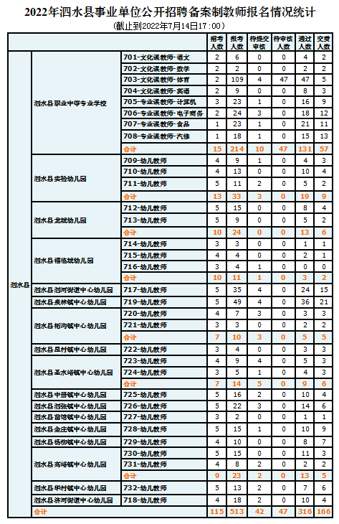](http://www.sishui.gov.cn/picture/0/1f15d9150fbd4996aa92bdfcc72774d0.png)