[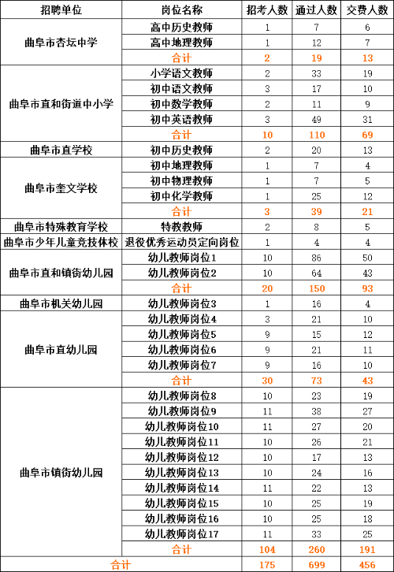](http://www.qufu.gov.cn/picture/0/6e51da36d2f84b86b611e10ccc7a4b3f.png)